# Required Components

**8**

|  |  |
| --- | --- |
| See the source image  **9**  **7**  **6**  **5**  **3**  **4**  **2**  **1** | **BOM**   1. Electric Water Gun 2. 3.5mm mono jack and nut 3. 2 pieces of wire 15cm long 4. Copper Tape 8mm long 5. Zip tie 6. 1cm x 1cm card stock or paper 7. 4 AA batteries 8. 1/4″-20 UNC Hex Bolt, 1/2″ Length 9. 1/4″-20 UNC Tee Nut Insert |

# Required Tools

* Drill with ¼” bit
* Small flat head or Phillips screwdriver (it must be skinny as the screws are in deep)
* Flush Cutters
* Wire Strippers
* Soldering Iron and Solder
* Scissors

# Required Personal Protective Equipment (PPE)

* Safety Glasses

# Assembly Instructions

## Step 1

Remove 13 screws from the side of the water gun as pictured.

|  |
| --- |
| a picture of a red and black small water gun |

## Step 2

Remove and set aside the half of the water gun that was held down by the screws.

|  |
| --- |
| A picture of the red and grey water gun opened up in half |

## Step 3

Remove any other screws that are holding down the black battery compartment or the grey water compartment. (Some seemed to have screws others did not).

|  |
| --- |
| A picture of the red and grey water gun opened up in half |

## Step 4

Remove the battery compartment and the water compartment from the water gun.

|  |
| --- |
| A picture of a black battery compartment connected to the grey water compartment of the water gun |

## Step 5

Remove screw from the top of the battery compartment.

|  |
| --- |
| A picture of the red cover on top of the battery compartment |

## Step 6

Using cardstock or paper, cut a small rectangle approximately 1cm x 1cm

|  |
| --- |
|  |

## Step 7

Cut 2 pieces of copper tape 8mm long (just shorter than the cardstock). Adhere the copper tape on both sides of the cardstock in the centre.

|  |
| --- |
|  |

## Step 8

Cut 2 pieces of wire 15cm long.

|  |
| --- |
|  |

## Step 9

Strip 0.5cm off both ends of the two wires.

|  |
| --- |
|  |

## Step 10

Solder one wire to one side of the copper tape and the second wire to the second side of the copper tape.

|  |
| --- |
|  |

## Step 11

Solder the other ends of the wires to the two mono jack legs closest to the nut or jack. This device is called a battery interrupter. It will later be placed in between the batteries of the device to allow for the assistive switch to be used instead of the trigger.

|  |
| --- |
|  |

## Step 12

Using flush cutters, cut a small slot out of the battery compartment in the position shown below. The slot should be big enough to fit 2 wires out of.

|  |  |
| --- | --- |
|  |  |

## Step 13

Insert 4x AA batteries into the battery compartment. Once done, insert the battery interrupter on top of the battery shown below. (It works best on this battery because it gets held down better as it is on the side closest to the battery cover screw. Also, the interrupter has a much easier time reaching the “spring” side of the battery cover which is why this battery position was chosen.)

|  |
| --- |
|  |

## Step 14

Screw the battery cover back on the battery compartment. Make sure the wires fall in the slot cut in Step 12 so they don’t interfere with the cover.

|  |
| --- |
|  |

## Step 15

Test the device. This will be done by plugging in an assistive switch into the jack. The switch on the water gun will have to be held in simultaneously when the switch is activated. If the water gun isn’t working, the battery interrupter likely moved out of place.

|  |
| --- |
|  |

## Step 16

Locate this half of the water gun. Drill a 1/4" hole in the gun in the location shown below. Make sure there is enough room for a mono jack to be placed wherever the hole is drilled.

|  |
| --- |
|  |

## Step 17

Remove the nut from the mono jack and push the mono jack through the hole. Reinstall the nut and tighten to secure.

|  |
| --- |
|  |

## Step 18

Place the battery compartment and the water compartment back in the gun. If there were any screws holding these parts down, put them back in.

|  |
| --- |
|  |

## Step 19

Reinsert the 13 screws to reattach the other side of the water gun.

|  |
| --- |
| a picture of a red and black small water gun |

## Step 20

Place a zip tie around the trigger on the water gun holding it in the on position. Cut any excess.

## Step 21

Place the tee nut teeth on the slits in the 3D printed base.

## Step 22

Thread the bolt through the nut and tighten until the tee nut is seated as far down as possible.

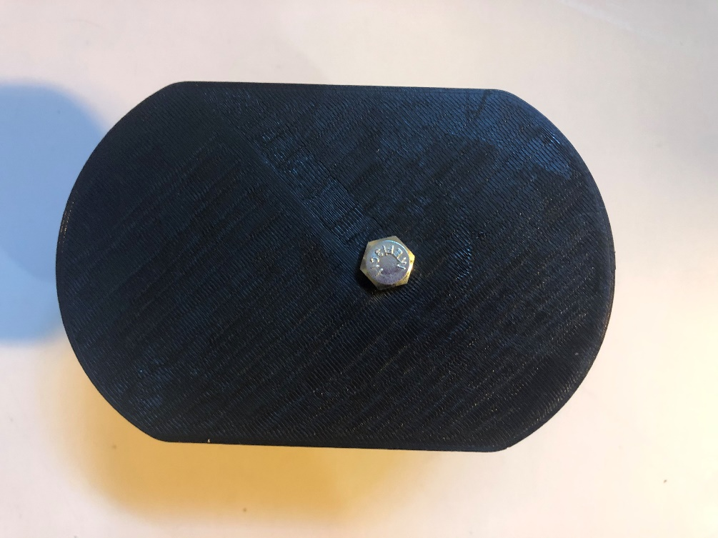

## Step 23

Unscrew and remove the bolt.

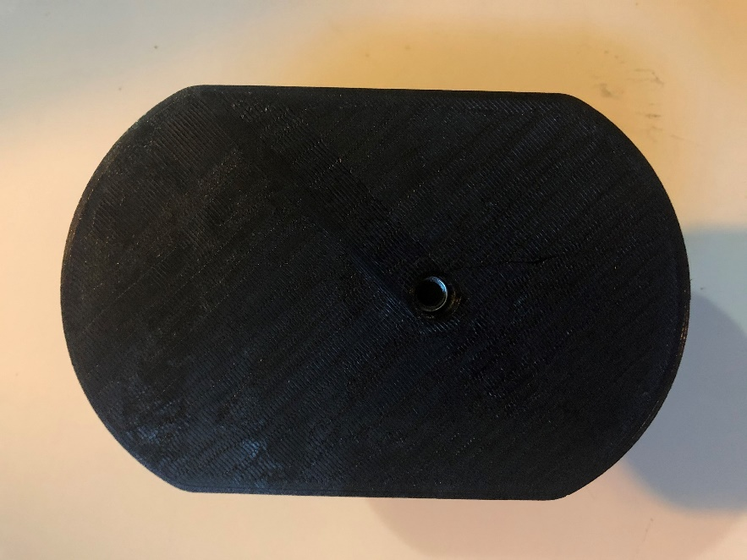

## Step 24

Place the water gun in the 3D printed base

